Part 1

- A 45 g piece of plasticine is placed in water and 30 cm³ of water was displaced.
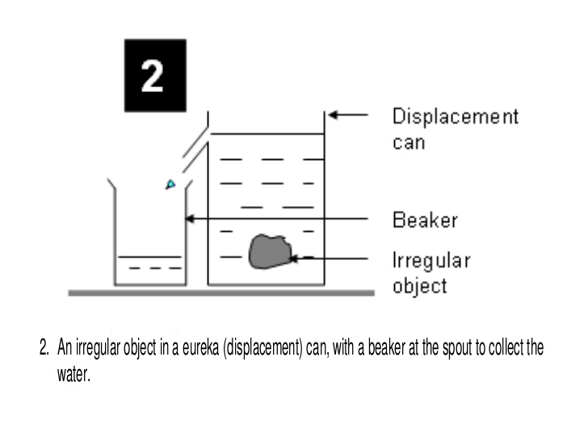
Calculate the density of the plasticine in kg/m³ (3)
Displacement can

Beaker
Water
Plasticine

……………………………………………………………………………………………………………………………………………………………………
……………………………………………………………………………………………………………………………………………………………………
……………………………………………………………………………………………………………………………………………………………………
……………………………………………………………………………………………………………………………………………………………………
- The density of solid copper is 8960 kg/m³.
The density of molten copper is 7900 kg/m³.
Explain this difference in density by referring to the particle model and the arrangement of
atoms in the two states. (2)

……………………………………………………………………………………………………………………………………………………………………
……………………………………………………………………………………………………………………………………………………………………
……………………………………………………………………………………………………………………………………………………………………
- House bricks have a density of 2100 kg/m³. If you require 15 m³ to build a house, what will the mass of these bricks be? (3)
……………………………………………………………………………………………………………………………………………………………………
……………………………………………………………………………………………………………………………………………………………………
……………………………………………………………………………………………………………………………………………………………………
……………………………………………………………………………………………………………………………………………………………………

- The particles in candle wax can be in solid, liquid or gaseous state. In the boxes below, draw the arrangement of particles you would expect in each of these three states. (3)

SOLID LIQUID GAS

- The diagram shows four different substances which have been placed in a basin of water. Which one of the following statements is TRUE? (1)
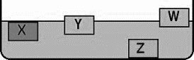
- Z is the densest and X is the least dense.

- Y is the least dense and Z is the densest.

- X has the same density as the water and W is the least dense. (1)

- Z is the densest and Y is the next densest.

- When a small block of iron is heated it becomes a liquid, but when thin iron wire is heated it becomes a black powder. Explain these observations in terms of physical and chemical changes. (3)

……………………………………………………………………………………………………………………………………………………………………
……………………………………………………………………………………………………………………………………………………………………
……………………………………………………………………………………………………………………………………………………………………
……………………………………………………………………………………………………………………………………………………………………

- In a closed energy system, E_{p} describes the potential energy of the particles and E_{k} the kinetic energy of the particles. How would you use these two values to calculate the total internal energy of the system (U)? (2)

……………………………………………………………………………………………………………………………………………………………………
……………………………………………………………………………………………………………………………………………………………………
……………………………………………………………………………………………………………………………………………………………………

- A cold spoon and an ice cube are placed in a cup of boiling water. Describe the effect the changes in internal energy will have on the spoon and the ice cube. (3)
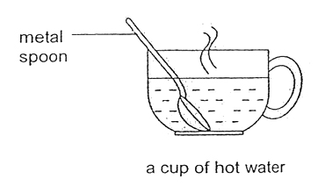
Cold spoon


Ice cube

- Which of the following statements best describes the term “specific heat capacity” (1)

A – the amount of internal heat energy contained in 1 kg of a substance.
B – the amount of heat energy conducted from 1 kg of an object to another.
C – The amount of heat energy needed to raise the temperature of 1 kg of a substance by 1 ⁰C. (1)

D - The time taken to raise the temperature of a block of metal by 1 ⁰C.
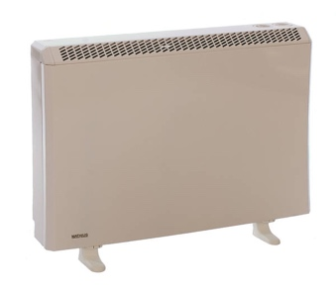
- A storage heater contains concrete bricks which heat up at
night and slowly release their heat the following day.
The bricks have a mass of 20 kg and they have 480 000 J of heat
energy transferred to them overnight.
Calculate the maximum temperature rise of the bricks. (3)

(Concrete has a specific heat capacity of 960 J/kg ⁰C)

Change in thermal energy = mass x specific heat capacity x temperature rise

……………………………………………………………………………………………………………………………………………………………………
……………………………………………………………………………………………………………………………………………………………………
……………………………………………………………………………………………………………………………………………………………………
……………………………………………………………………………………………………………………………………………………………………
……………………………………………………………………………………………………………………………………………………………………

- Describe what is meant by the specific latent heat of a substance. (1)

……………………………………………………………………………………………………………………………………………………………………
……………………………………………………………………………………………………………………………………………………………………
- A 200 g sample of ice is at a temperature of 0 ⁰C. How much heat energy will be required to melt this sample of ice without raising its temperature?
The specific latent heat of melting ice is 334 000 J/kg. (2)

Energy to change state = mass x specific latent heat

……………………………………………………………………………………………………………………………………………………………………
……………………………………………………………………………………………………………………………………………………………………
……………………………………………………………………………………………………………………………………………………………………

- The graph shows the temperature of a block of solid wax as it is heated.
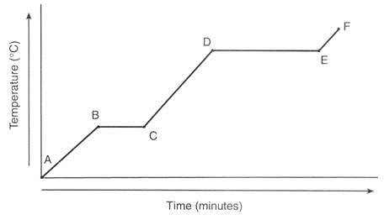
Heating curve for a block of wax

- What state will the wax be in between points E and F on the graph? (1)

……………………………………………………………………………………………………………………………………………………………………
……………………………………………………………………………………………………………………………………………………………………
- Why is the temperature between B and C not rising? (2)

……………………………………………………………………………………………………………………………………………………………………
……………………………………………………………………………………………………………………………………………………………………
……………………………………………………………………………………………………………………………………………………………………

- Which point shows the maximum temperature of liquid wax? (1)

……………………………………………………………………………………………………………………………………………………………………
……………………………………………………………………………………………………………………………………………………………………
……………………………………………………………………………………………………………………………………………………………………

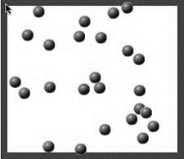
- The diagram shows particles of a gas moving around inside a sealed container.

- If the container is heated up, which of the statements below is true? (1)
A. The gas particles move closer together.
B. The gas particles move slower.
C. The gas particles have more kinetic energy.
D. The gas particles expand.
- What happens to the pressure in the box as the gas is heated? (1)

A. Pressure increases as gas particles have higher speed collisions with the container walls

B. Pressure is the same as there are the same number of particles in the box

C. Pressure increases as the gas particles expand
D. Pressure is the same because the mass of each particle does not change

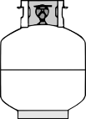
- The diagram shows a gas bottle filled with propane gas at a temperature of 12 ⁰C.
The bottle is left in the sunshine and the temperature of the gas gradually increases.

- What will happen to the number of particles of gas in the bottle? (1)

……………………………………………………………………………………………………………………………………………………………………
……………………………………………………………………………………………………………………………………………………………………
- What will happen to the pressure of gas inside the bottle as the temperature rises? (1)

……………………………………………………………………………………………………………………………………………………………………
……………………………………………………………………………………………………………………………………………………………………

- On the graph below, sketch the shape you would expect if temperature and pressure were
plotted as the temperature gradually rises. (1)
Temperature of the gas

Pressure of the gas

Part 2

- The diagram shows the movement of gas particles inside a fixed metal container at 20 ⁰C.
The temperature is increased to 50 ⁰C.
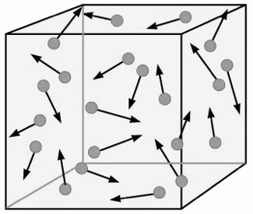

- Describe the change in average velocity of the gas particles as a result of this temperature
change. (1)

……………………………………………………………………………………………………………………………………………………………………
……………………………………………………………………………………………………………………………………………………………………
- Explain why the pressure on the walls of the container increases with this temperature
change. (3)
……………………………………………………………………………………………………………………………………………………………………
……………………………………………………………………………………………………………………………………………………………………
……………………………………………………………………………………………………………………………………………………………………
……………………………………………………………………………………………………………………………………………………………………

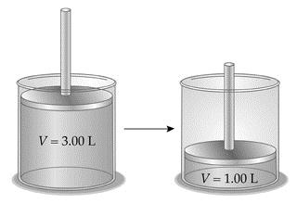

- A piston contains 1 litre of air. The plunger is lifted so
the same mass of gas now occupies 3 litres.

- Use the particle model to explain why the pressure
on the piston wall will be reduced when the
plunger is lifted. (2)

……………………………………………………………………………………………………………………………………………………………………
……………………………………………………………………………………………………………………………………………………………………
………………………………………………………………………………………………………………………………………………………

- In what direction is the force exerted on the
piston walls? (1)

……………………………………………………………………………………………………………………………………………………………………
……………………………………………………………………………………………………………………………………………………………………

- If the pressure of the gas when it occupies a volume of I litre is 100 000 Pa, calculate the gas pressure when the volume is 3 litres. (2)

Pressure x volume = constant

……………………………………………………………………………………………………………………………………………………………………
……………………………………………………………………………………………………………………………………………………………………
……………………………………………………………………………………………………………………………………………………………………

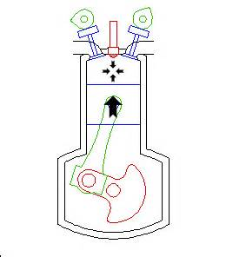
- In a car diesel engine, work is done on the fuel/air mixture
to ignite it. Explain why the fuel ignites when there is no spark
in the diesel engine. (3)

……………………………………………………………………………………………………………………………………………………………………
……………………………………………………………………………………………………………………………………………………………………
……………………………………………………………………………………………………………………………………………………………………
……………………………………………………………………………………………………………………………………………………………………
……………………………………………………………………………………………………………………………………………………………………

